

**KAUNAS UNIVERSITY OF TECHNOLOGY**

**FACULTY OF INFORMATICS**

**COMPUTER DEPARTMENT**

### App Development for Smart Mobile Systems 1st Labaratory work

**Assignment completed by:**

IFF 6/8 group student

Tadas Laurinaitis

**Assignment evaluated by**:

Prof. Rytis Maskeliūnas

### Table of contents:

Contents

App Development for Smart Mobile Systems 1st Labaratory work 1

Table of contents: 2

Tasks: 3

Text describing how each task was solved: 3

Literature list: 13

### Tasks:

### Text describing how each task was solved:

Task #1: Task is self explanatory, button component was deleted from the first activity class.

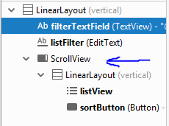Task #2: I have completed this task by adding Scrollview components to both “firstactivitylayout” and “secondactivitylayout” layout files, and then nested ListView component inside it.

**Picture #1 showing the component tree after adding ScrollView component**

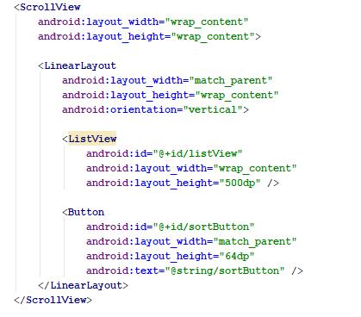**Picture #2 showing the XML code of the layout after adding ScrollView component**

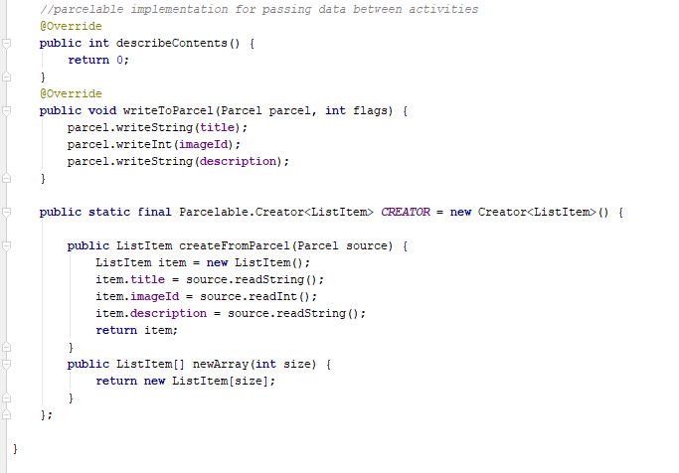Task #3: The task was completed by using Android implementation of Java Serializable called “Parcelable”. Implementing it allowed me to transfer an ArrayList, containing ListItem object data from the first activity to the second one. I also created a method in firstActivity class, which provides some starting data, so that the list wouldn’t be empty if no one entered anything.

**Picture #3 showing the implementation of Parcelable into ListItem class**

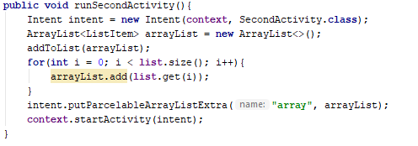

**Picture #4 showing usage of intent‘s putParcelableArrayListExtra method for data transition between the first and second activities.**

**Picture #5 showing the code lines in secondActivity class which are responsible for parsing data from firstActivity class through intent.**

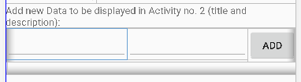Task #4: **For this task I created two EditText elements and one button element inside my firstactivitylayout layout file. One of the EditText elements is responsible for getting title of my ListItem class, and the other one is responsible for getting description. After clicking the button, which I called „ADD“, data from both EditText components is read and the new ListItem object is created using that data.**

**Picture #6 showing the design of 2 EditText and 1 button elements**

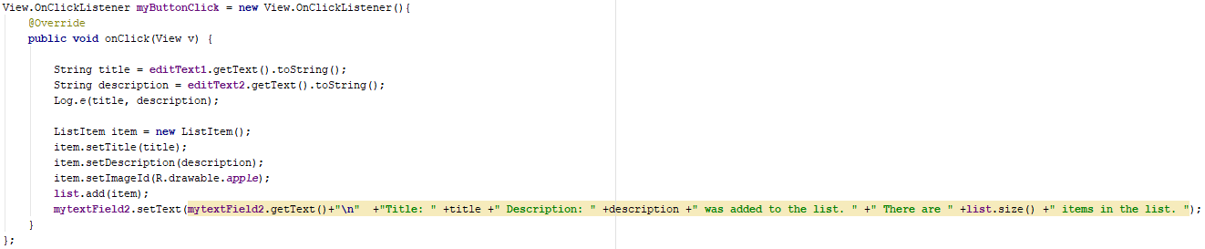**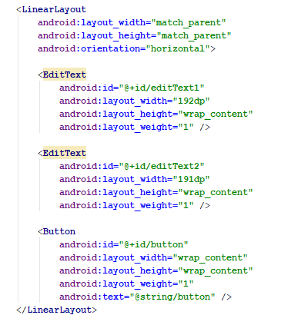Picture #7 showing XML code of the elements showed before**

**Picture #8 showing onClick method of „ADD“ button**

**Task #5: For this task, I have created a new java file called ThirdActivity, a new layout file containing 3 elements: ImageView element and two TextView elements. After that, I wrote code which made everything work.**

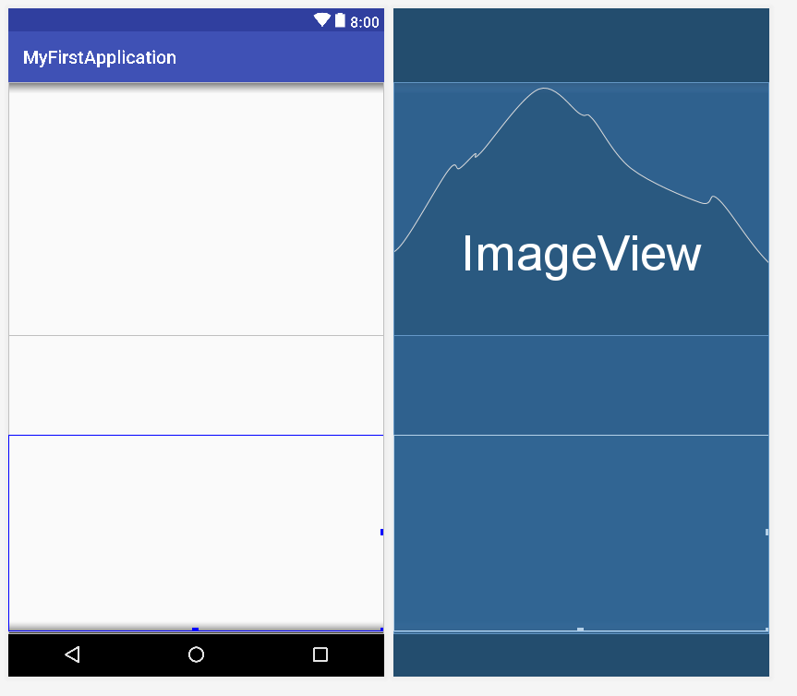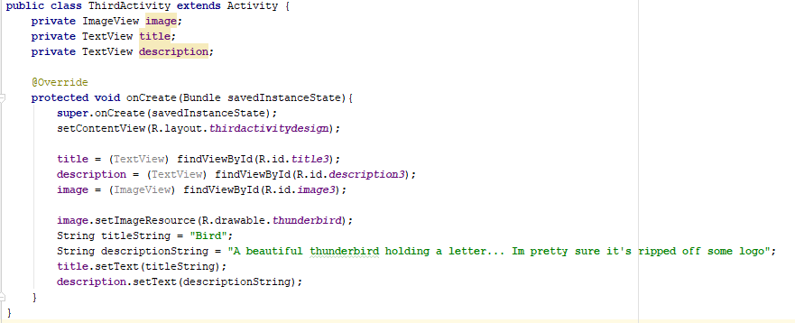**Picture #9 showing ThirdActivity class**

**Picture #10 showing design of the thirdactivitylayout layout file**

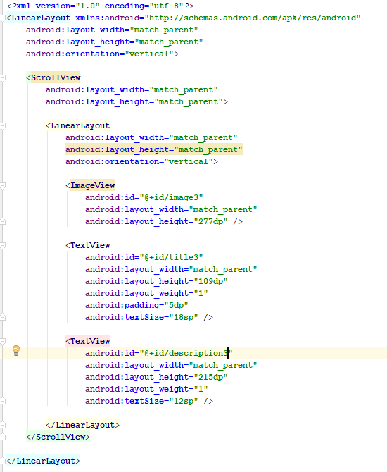**Picture #11 showing XML file of the thirdactivitylayout file**

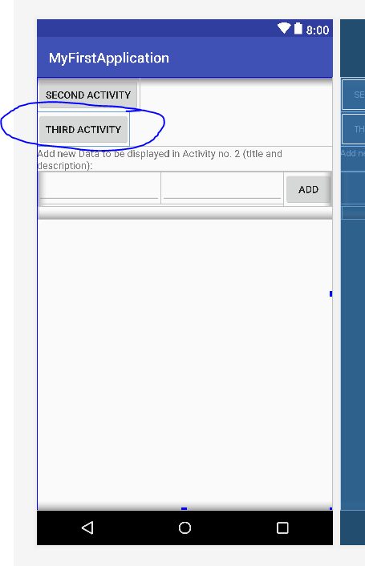**Picture #12 showing a button in firstactivitylayout which is used to access thirdactivitylayout and ThirdActivity class**

Task #6:For this task I added a button, which when pressed uses a simple sorting algorithm inside my SecondActivity class. Sorting algorithm compares titles of ListItem objects and puts them in alphabetical order.

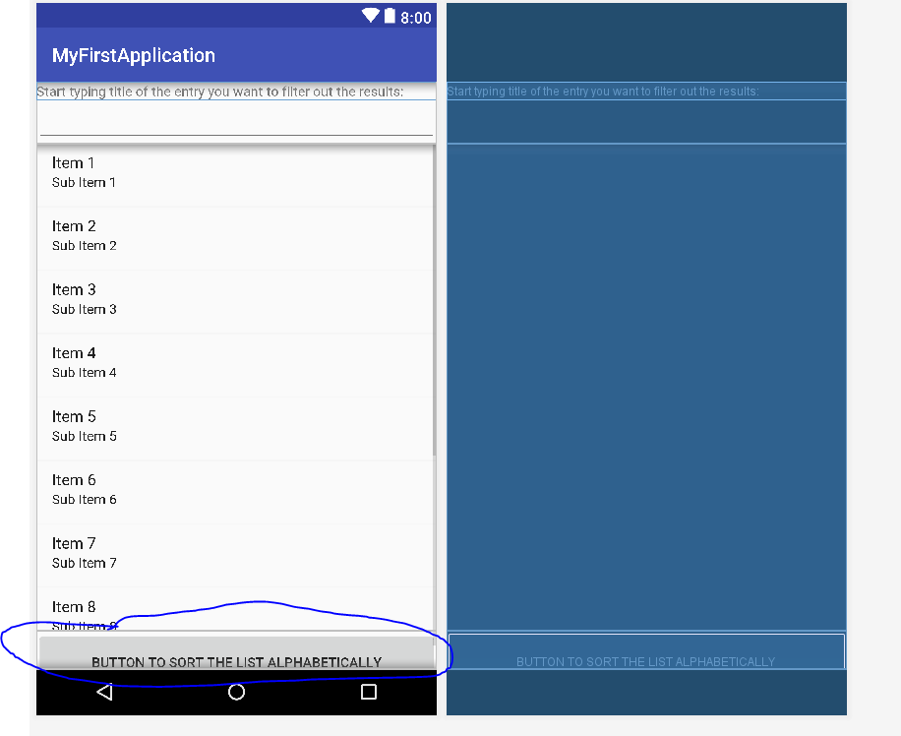

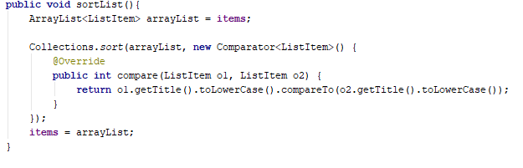**Picture #13 showing a button which calls sorting algorithm and sorts the whole list**

**Picture #14 showing the sorting algorithm used to sort the list**

Task #7:For this task I created a new EditText element on top of the list in my secondactivitylayout layout file, and then wrote an algorithm which uses onTextChanged method of TextWatcher class to detect when and to what the text was changed.

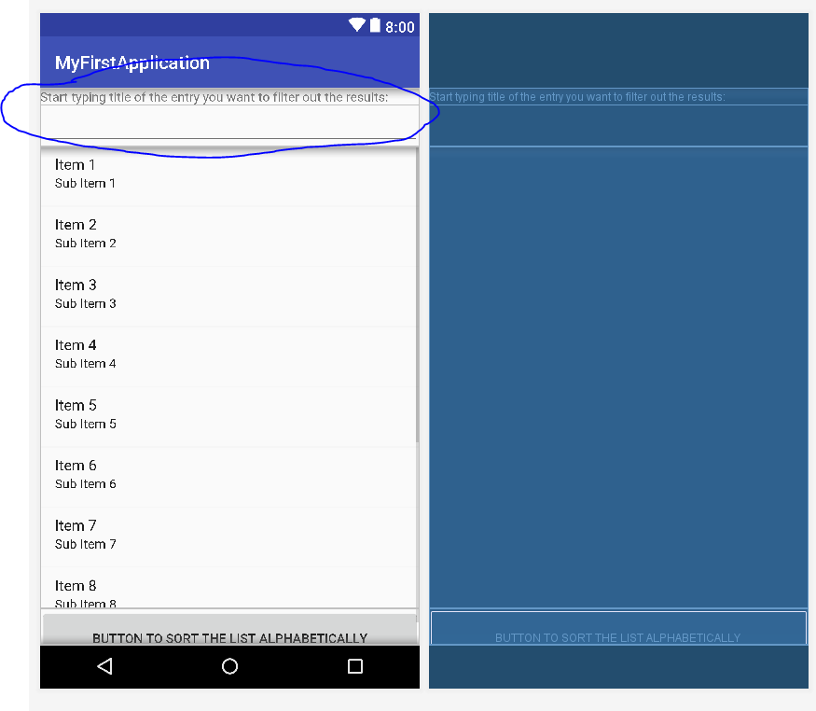**Picture #15 showing EditText element which is used to filter the items above it by title**

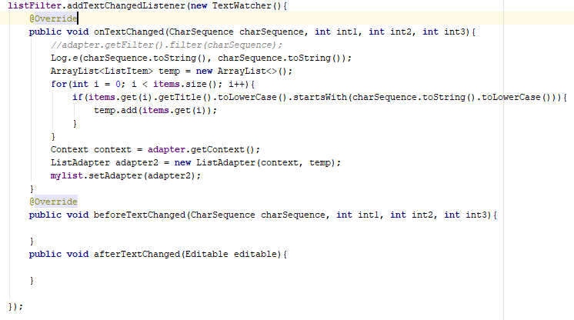**Picture #16 showing the filtering algorithm used in SecondActivity class**

### ****Literature list:****

<https://developer.android.com/guide/topics/resources/drawable-resource#java>

<https://www.kisspng.com/png-apple-png-vector-element-26368/download-png.html>

<http://resizeimage.net/>

<https://stackoverflow.com/questions/20169993/how-to-transfer-data-from-one-activity-to-another-in-android>

<https://stackoverflow.com/questions/49249234/what-is-parcelable-in-android>

<https://developer.android.com/reference/android/os/Parcelable.Creator>

<https://stackoverflow.com/questions/12092612/pass-list-of-objects-from-one-activity-to-other-activity-in-android>

<https://stackoverflow.com/questions/2784514/sort-arraylist-of-custom-objects-by-property>

<https://stackoverflow.com/questions/9790584/how-to-check-if-a-string-starts-with-one-of-several-prefixes>

### ****Full source code of my tasks:****

FirstActivity.java

**package** com.example.destroyer.lab1;  
  
**import** android.app.Activity;  
**import** android.content.Context;  
**import** android.content.Intent;  
**import** android.os.Bundle;  
**import** android.os.Parcelable;  
**import** android.support.v7.app.AppCompatActivity;  
**import** android.util.Log;  
**import** android.view.View;  
**import** android.widget.Button;  
**import** android.widget.EditText;  
**import** android.widget.TextView;  
  
**import** java.util.ArrayList;  
**import** java.util.List;  
  
**public class** FirstActivity **extends** Activity {  
  
 **private** TextView **mytextField**;  
 **private** TextView **mytextField2**;  
 **private** EditText **editText1**;  
 **private** EditText **editText2**;  
 **private** Button **myButton**;  
 **private** Button **secondActivityButton**;  
 **private** Button **thirdActivityButton**;  
 **private** Context **context** = **this**;  
 **private** ArrayList<ListItem> **list**;  
  
  
 @Override  
 **protected void** onCreate(Bundle savedInstanceState){  
 **super**.onCreate(savedInstanceState);  
 setContentView(R.layout.***firstactivitydesign***);  
 **list** = **new** ArrayList<>();  
  
 **secondActivityButton** = (Button) findViewById(R.id.***secondActivityButton***);  
 **thirdActivityButton** = (Button) findViewById(R.id.***thirdActivityButton***);  
 **myButton** = (Button) findViewById(R.id.***button***);  
 **mytextField** = (TextView) findViewById(R.id.***textfield***);  
 **mytextField2** = (TextView) findViewById(R.id.***textfield2***);  
 **editText1** = (EditText) findViewById(R.id.***editText1***);  
 **editText2** = (EditText) findViewById(R.id.***editText2***);  
  
 **myButton**.setOnClickListener(**myButtonClick**);  
 **secondActivityButton**.setOnClickListener(**startSecondActivity**);  
 **secondActivityButton**.setOnLongClickListener(**startSecondActivityLong**);  
 **thirdActivityButton**.setOnClickListener(**startThirdActivity**);  
 }  
  
 View.OnClickListener **myButtonClick** = **new** View.OnClickListener(){  
 @Override  
 **public void** onClick(View v) {  
  
 String title = **editText1**.getText().toString();  
 String description = **editText2**.getText().toString();  
 Log.*e*(title, description);  
  
 ListItem item = **new** ListItem();  
 item.setTitle(title);  
 item.setDescription(description);  
 item.setImageId(R.drawable.***apple***);  
 **list**.add(item);  
 **mytextField2**.setText(**mytextField2**.getText()+**"\n"** +**"Title: "** +title +**" Description: "** +description +**" was added to the list. "** +**" There are "** +**list**.size() +**" items in the list. "**);  
 }  
 };  
 **public void** runSecondActivity(){  
 Intent intent = **new** Intent(**context**, SecondActivity.**class**);  
 ArrayList<ListItem> arrayList = **new** ArrayList<>();  
 addToList(arrayList);  
 **for**(**int** i = 0; i < **list**.size(); i++){  
 arrayList.add(**list**.get(i));  
 }  
 intent.putParcelableArrayListExtra(**"array"**, arrayList);  
 **context**.startActivity(intent);  
 }  
  
 View.OnClickListener **startSecondActivity** = **new** View.OnClickListener(){  
 @Override  
 **public void** onClick(View v){  
 runSecondActivity();  
 }  
 };  
 View.OnLongClickListener **startSecondActivityLong** = **new** View.OnLongClickListener(){  
 @Override  
 **public boolean** onLongClick(View v){  
 runThirdActivity();  
 **return true**;  
 }  
 };  
 **public void** runThirdActivity(){  
 Intent intent = **new** Intent(**context**, ThirdActivity.**class**);  
 **context**.startActivity(intent);  
 }  
 View.OnClickListener **startThirdActivity** = **new** View.OnClickListener(){  
 @Override  
 **public void** onClick(View v){  
 runThirdActivity();  
 }  
 };  
  
 **public void** addToList(ArrayList<ListItem> list){  
 list.add(**new** ListItem(**"Mad"**, R.drawable.***apple***, **"Mathematics ir the worse version of Chemistry"**));  
 list.add(**new** ListItem(**"Uncle"**, R.drawable.***apple***, **"Chemistry is the worse version of Biology"**));  
 list.add(**new** ListItem(**"Ross"**, R.drawable.***apple***, **"Mathematics is the worse version of Physics"**));  
 list.add(**new** ListItem(**"Jim"**, R.drawable.***apple***, **"Mathematics and Chemistry are both equaly bad"**));  
 list.add(**new** ListItem(**"Frank"**, R.drawable.***apple***, **"Mathematics, Chemistry and Biology are all sciences of the SATAN"**));  
 list.add(**new** ListItem(**"Caspar"**, R.drawable.***apple***, **"Mathematics ir the worse version of Geography"**));  
 list.add(**new** ListItem(**"Zeek"**, R.drawable.***apple***, **"Chemistry is the worse version of Neuroscience"**));  
 list.add(**new** ListItem(**"Milkman"**, R.drawable.***apple***, **"Mathematics is the worse version of Polythology"**));  
 list.add(**new** ListItem(**"Chain"**, R.drawable.***apple***, **"Mathematics and Religion are both equaly bad"**));  
 list.add(**new** ListItem(**"Moses"**, R.drawable.***apple***, **"Mathematics, Chemistry and Paleonthology are all sciences of the SATAN"**));  
 list.add(**new** ListItem(**"Alpoint"**, R.drawable.***apple***, **"Mathematics ir the worse version of Voodoo"**));  
 list.add(**new** ListItem(**"Albino"**, R.drawable.***apple***, **"Chemistry is the worse version of Biology"**));  
 list.add(**new** ListItem(**"Kim"**, R.drawable.***apple***, **"Ethics is the worse version of Physics"**));  
 list.add(**new** ListItem(**"Saloon"**, R.drawable.***apple***, **"Dances and fortnite emotes are both equaly bad"**));  
 list.add(**new** ListItem(**"Fibby"**, R.drawable.***apple***, **"Mathematics, Chemistry and Biology are all sciences of the SATAN"**));  
 }  
}

SecondActivity.java

**package** com.example.destroyer.lab1;  
  
**import** android.app.Activity;  
**import** android.content.Context;  
**import** android.content.Intent;  
**import** android.os.Bundle;  
**import** android.text.Editable;  
**import** android.text.TextWatcher;  
**import** android.util.Log;  
**import** android.view.View;  
**import** android.widget.Button;  
**import** android.widget.EditText;  
**import** android.widget.ListView;  
**import** android.widget.TextView;  
  
**import** org.w3c.dom.Text;  
  
**import** java.util.ArrayList;  
**import** java.util.Collections;  
**import** java.util.Comparator;  
**import** java.util.List;  
  
**public class** SecondActivity **extends** Activity {  
  
 **private** ListView **mylist**;  
 **private** ListAdapter **adapter**;  
 **private** ArrayList<ListItem> **items**;  
 **private** Button **sortButton**;  
 **private** EditText **listFilter**;  
 **private** TextView **filterTextField**;  
  
 @Override  
 **protected void** onCreate(Bundle savedInstanceState){  
 **super**.onCreate(savedInstanceState);  
 setContentView(R.layout.***secondactivitydesign***);  
 **mylist** = (ListView) findViewById(R.id.***listView***);  
 **sortButton** = (Button) findViewById(R.id.***sortButton***);  
 **sortButton**.setOnClickListener(**sortList**);  
 **listFilter** = (EditText)findViewById(R.id.***listFilter***);  
 **filterTextField** = (TextView) findViewById(R.id.***filterTextField***);  
 *//getting list of ListItems from the first activity* Intent intent = getIntent();  
 **items** = intent.getParcelableArrayListExtra (**"array"**);  
 *//----------------------------------------------------* **adapter** = **new** ListAdapter(**this**, **items**);  
 **mylist**.setAdapter(**adapter**);  
 **listFilter**.addTextChangedListener(**new** TextWatcher(){  
 @Override  
 **public void** onTextChanged(CharSequence charSequence, **int** int1, **int** int2, **int** int3){  
 *//adapter.getFilter().filter(charSequence);* Log.*e*(charSequence.toString(), charSequence.toString());  
 ArrayList<ListItem> temp = **new** ArrayList<>();  
 **for**(**int** i = 0; i < **items**.size(); i++){  
 **if**(**items**.get(i).getTitle().toLowerCase().startsWith(charSequence.toString().toLowerCase())){  
 temp.add(**items**.get(i));  
 }  
 }  
 Context context = **adapter**.getContext();  
 ListAdapter adapter2 = **new** ListAdapter(context, temp);  
 **mylist**.setAdapter(adapter2);  
 }  
 @Override  
 **public void** beforeTextChanged(CharSequence charSequence, **int** int1, **int** int2, **int** int3){  
  
 }  
 **public void** afterTextChanged(Editable editable){  
  
 }  
  
 });  
 }  
  
 View.OnClickListener **sortList** = **new** View.OnClickListener(){  
 @Override  
 **public void** onClick(View v){  
 sortList();  
 **mylist**.setAdapter(**adapter**);  
 }  
 };  
  
 **public void** sortList(){  
 ArrayList<ListItem> arrayList = **items**;  
  
 Collections.*sort*(arrayList, **new** Comparator<ListItem>() {  
 @Override  
 **public int** compare(ListItem o1, ListItem o2) {  
 **return** o1.getTitle().toLowerCase().compareTo(o2.getTitle().toLowerCase());  
 }  
 });  
 **items** = arrayList;  
 }  
}

ThirdActivity.java

**package** com.example.destroyer.lab1;  
  
**import** android.app.Activity;  
**import** android.os.Bundle;  
**import** android.widget.Button;  
**import** android.widget.ImageView;  
**import** android.widget.TextView;  
  
**public class** ThirdActivity **extends** Activity {  
 **private** ImageView **image**;  
 **private** TextView **title**;  
 **private** TextView **description**;  
  
 @Override  
 **protected void** onCreate(Bundle savedInstanceState){  
 **super**.onCreate(savedInstanceState);  
 setContentView(R.layout.***thirdactivitydesign***);  
  
 **title** = (TextView) findViewById(R.id.***title3***);  
 **description** = (TextView) findViewById(R.id.***description3***);  
 **image** = (ImageView) findViewById(R.id.***image3***);  
  
 **image**.setImageResource(R.drawable.***thunderbird***);  
 String titleString = **"Bird"**;  
 String descriptionString = **"A beautiful thunderbird holding a letter... Im pretty sure it's ripped off some logo"**;  
 **title**.setText(titleString);  
 **description**.setText(descriptionString);  
 }  
}

ListAdapter.java

**package** com.example.destroyer.lab1;  
  
**import** android.content.Context;  
**import** android.media.Image;  
**import** android.view.LayoutInflater;  
**import** android.view.View;  
**import** android.view.ViewGroup;  
**import** android.widget.ArrayAdapter;  
**import** android.widget.ImageView;  
**import** android.widget.TextView;  
  
**import** java.util.List;  
  
**public class** ListAdapter **extends** ArrayAdapter<ListItem> {  
  
 **public** ListAdapter(Context context, List<ListItem> objects){  
 **super**(context, R.layout.***listitemdesign***, objects);  
 }  
  
 @Override  
 **public** View getView(**int** position, View convertView, ViewGroup parent){  
  
 View v = convertView;  
  
 **if**(v == **null**){  
 LayoutInflater inflater = (LayoutInflater) getContext().getSystemService(Context.***LAYOUT_INFLATER_SERVICE***);  
 v = inflater.inflate(R.layout.***listitemdesign***, **null**);  
 }  
  
 TextView title = (TextView) v.findViewById(R.id.***title***);  
 TextView description = (TextView) v.findViewById(R.id.***description***);  
 ImageView image = (ImageView) v.findViewById(R.id.***image***);  
  
 ListItem item = getItem(position);  
  
 title.setText(item.getTitle());  
 description.setText(item.getDescription());  
 image.setImageResource(item.getImageId());  
  
 **return** v;  
 }  
}

ListItem.java

**package** com.example.destroyer.lab1;  
  
**import** android.os.Parcel;  
**import** android.os.Parcelable;  
  
**public class** ListItem **implements** Parcelable{  
 **private** String **title**;  
 **private int imageId**;  
 **private** String **description**;  
  
 **public** ListItem(){  
 }  
  
 **public** ListItem(String title, **int** imageId, String description){  
 **this**.**title** = title;  
 **this**.**imageId** = imageId;  
 **this**.**description** = description;  
 }  
 *//getters and setters* **public** String getTitle(){  
 **return title**;  
 }  
  
 **public void** setTitle(String title){  
 **this**.**title** = title;  
 }  
  
 **public int** getImageId(){  
 **return imageId**;  
 }  
  
 **public void** setImageId(**int** imageId){  
 **this**.**imageId** = imageId;  
 }  
  
 **public** String getDescription(){  
 **return description**;  
 }  
  
 **public void** setDescription(String description){  
 **this**.**description** = description;  
 }  
  
 *//parcelable implementation for passing data between activities* @Override  
 **public int** describeContents() {  
 **return** 0;  
 }  
 @Override  
 **public void** writeToParcel(Parcel parcel, **int** flags) {  
 parcel.writeString(**title**);  
 parcel.writeInt(**imageId**);  
 parcel.writeString(**description**);  
 }  
  
 **public static final** Parcelable.Creator<ListItem> ***CREATOR*** = **new** Creator<ListItem>() {  
  
 **public** ListItem createFromParcel(Parcel source) {  
 ListItem item = **new** ListItem();  
 item.**title** = source.readString();  
 item.**imageId** = source.readInt();  
 item.**description** = source.readString();  
 **return** item;  
 }  
 **public** ListItem[] newArray(**int** size) {  
 **return new** ListItem[size];  
 }  
 };  
  
}